Rehnoor Aulakh

102317137

2Q16

Q1 Binary Search Program

#include<iostream>

using namespace std;

int BinarySearch(int arr[], int num, int low, int high)

{

if(low<high)

{

int mid=(low+high)/2;

if(arr[mid]==num)

{

return mid;

}

else if(arr[mid]<num)

{

//go right

low=mid+1;

}

else

{

high=mid-1;

}

return BinarySearch(arr,num,low,high);

}

else

{

return -1;

}

}

int main()

{

int num;

int arr[] = {2, 5, 8, 12, 16, 23, 38, 56, 72, 91};

cout<<"Enter Number to find in array: ";

cin>>num;

int res=BinarySearch(arr,num,0,sizeof(arr)/sizeof(int));

if(res==-1)

{

cout<<"Number not found"<<endl;

}

else

{

cout<<"Number found at index "<<res<<endl;

}

}

Output

Enter Number to find in array: 23

Number found at index 5

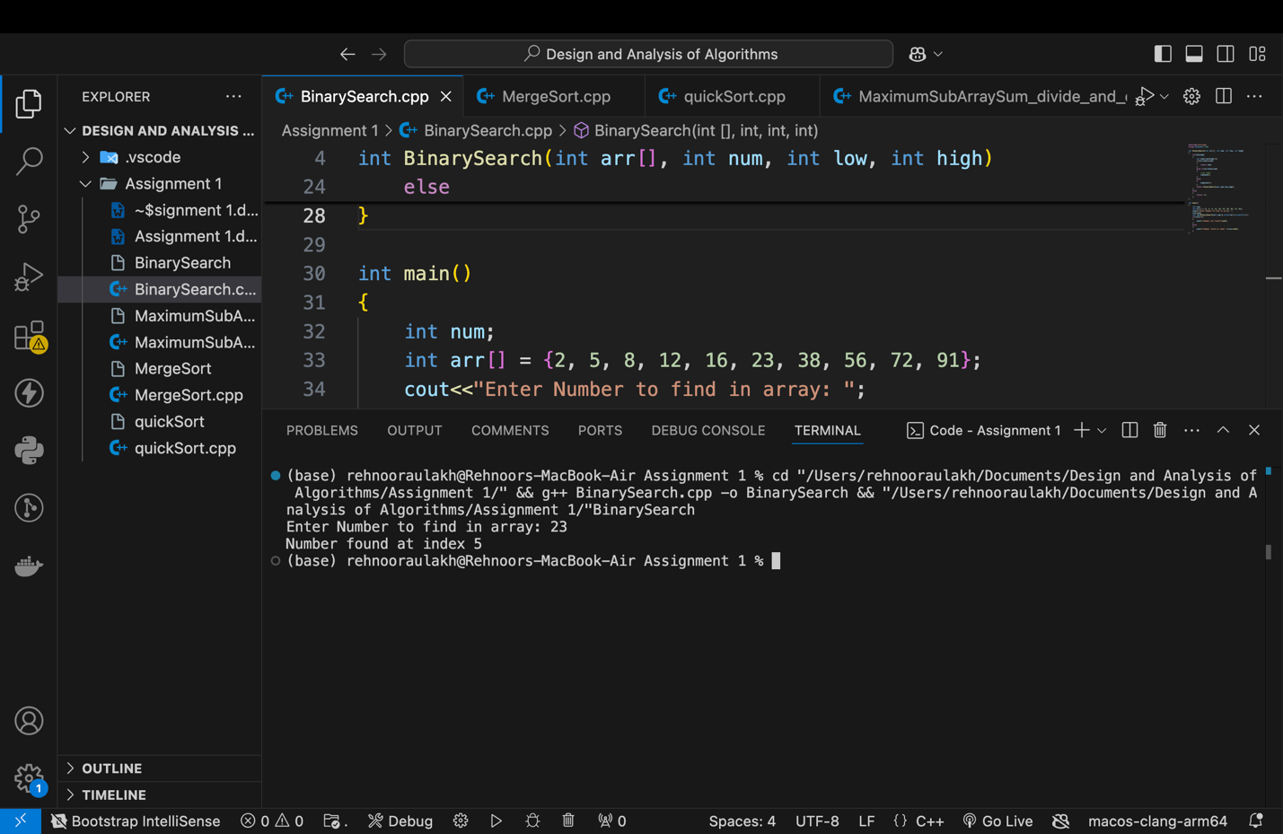

Q2 Merge Sort

#include <iostream>

using namespace std;

void merge(int arr[], int low, int mid, int high) {

int n1 = mid - low + 1;

int n2 = high - mid;

int left[n1], right[n2];

for (int i = 0; i < n1; i++)

left[i] = arr[low + i];

for (int j = 0; j < n2; j++)

right[j] = arr[mid + 1 + j];

int i = 0, j = 0, k = low;

while (i < n1 && j < n2) {

if (left[i] <= right[j]) {

arr[k] = left[i];

i++;

} else {

arr[k] = right[j];

j++;

}

k++;

}

while (i < n1) {

arr[k] = left[i];

i++;

k++;

}

while (j < n2) {

arr[k] = right[j];

j++;

k++;

}

}

void mergeSort(int arr[], int low, int high) {

if (low < high) {

int mid = (low + high) / 2;

mergeSort(arr, low, mid);

mergeSort(arr, mid + 1, high);

merge(arr, low, mid, high);

}

}

int main() {

int arr[] = {12, 11, 13, 5, 6, 7};

int arr_size = sizeof(arr) / sizeof(arr[0]);

mergeSort(arr, 0, arr_size - 1);

for (int i = 0; i < arr_size; i++) {

cout << arr[i] << " ";

}

cout << endl;

return 0;

}

Output

5 6 7 11 12 13

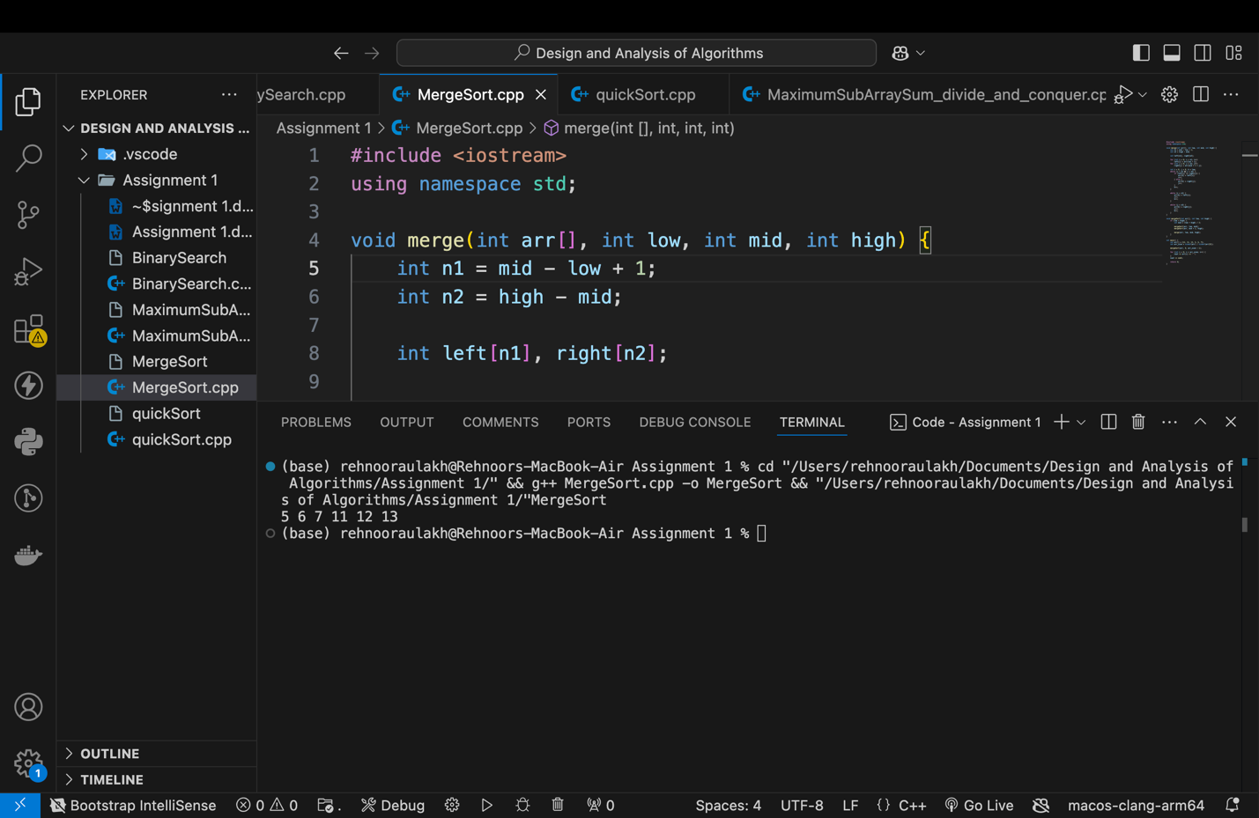

Q3 Quick Sort

#include<iostream>

using namespace std;

void quickSort(int arr[],int L,int U)

{

if(L<U)

{

int pivot=U;

int i=L-1;

// O(N) time for partition algorithm

for(int j=L;j<U;j++)

{

if(arr[j]<=arr[pivot])

{

i++;

//swap arr[i] with arr[j]

int t=arr[i];

arr[i]=arr[j];

arr[j]=t;

}

}

//swap pivot with i+1 position

int t=arr[i+1];

arr[i+1]=arr[pivot];

arr[pivot]=t;

//now recursive calls for quick sort O(logN) time because dividing into half

quickSort(arr,L,i);

quickSort(arr,i+2,U);

}

}

int main()

{

int arr[]={ 4, 2, 6, 9, 2 };

quickSort(arr,0,sizeof(arr)/sizeof(int)-1);

for(int i=0;i<sizeof(arr)/sizeof(int);i++)

{

cout<<arr[i]<<" ";

}

cout<<endl;

}

Output

2 2 4 6 9

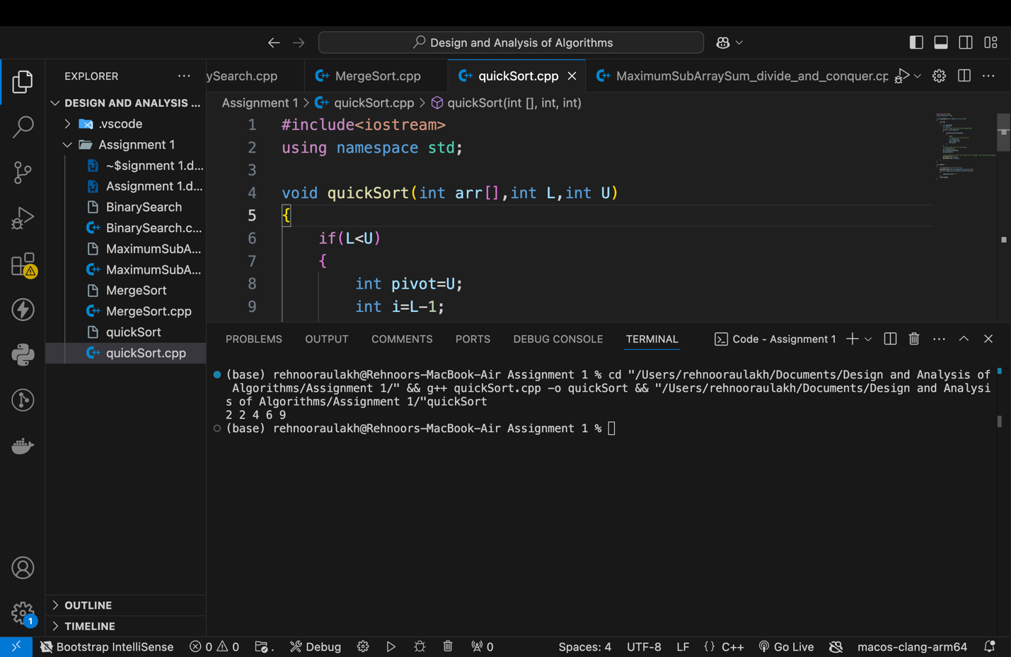

Q4 Maximum Subarray Sum

#include<iostream>

using namespace std;

//Function to find the maximum crossing subarray sum

int maxCrossingSum(int arr[],int l, int m, int h)

{

int sum=0;

int left_sum=INT_MIN;

for(int i=m;i>=l;i--)

{

sum+=arr[i];

if(sum>left_sum)

{

left_sum=sum;

}

}

sum=0;

int right_sum=INT_MIN;

for(int i=m+1;i<=h;i++)

{

sum+=arr[i];

if(sum>right_sum)

{

right_sum=sum;

}

}

return left_sum+right_sum;

}

//function to find the maximum subarray sum using divide and conquer

int maxSubArraySum(int arr[], int l, int h)

{

//base case, single element

if(l==h)

{

return arr[l];

}

int m=(l+h)/2;

return max(max(maxSubArraySum(arr,l,m),maxSubArraySum(arr,m+1,h)),maxCrossingSum(arr,l,m,h));

}

int main()

{

int arr[]= {-2, -5, 6, -2, -3, 1, 5, -6};

int n=sizeof(arr)/sizeof(int);

cout<<"Maximum Subarray sum is: "<<maxSubArraySum(arr,0,n-1)<<endl;

}

Output

Maximum Subarray sum is: 7

